**Project Design Phase-II**

**Data Flow Diagram**

|  |  |
| --- | --- |
| Date | 25 October 2023 |
| Team ID | 593505 |
| Project Name | AI System That Verifies User Identities Based On Their Online Behavior Patterns, Adding An Extra Layer Of Security |
| Maximum Marks | 4 Marks |

**Data Flow Diagrams:**

A Data Flow Diagram (DFD) is a traditional visual representation of the information flows within a system. A neat and clear DFD can depict the right amount of the system requirement graphically. It shows how data enters and leaves the system, what changes the information, and where data is stored.

DFD Level 0 (Industry Standard)

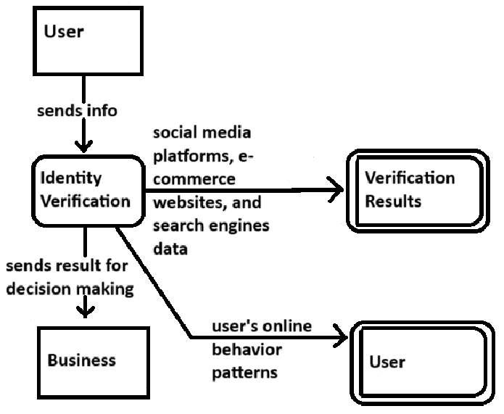

External entities: rectangle

Process: rounded rectangle

Data store: parallel lines